## 

## South End Community Day Care Website

## User Manual

### 

### 

### 

### 

### 

### 

### 

### 

### 

### 

### 

### Aleysha Mullen

Negin Sauermann

Angela Dini

Rami Khashmelous

Azeem Ali

## 

## Table of Contents

**Summary** . . . . . . . . . . . . . . . . . . . . . . . . . . . . . . . . . . . . . . . . . . . . . . . . . . . . . . . . . . . . . . . . . . . . . . . . . . . . . 2

**Description** . . . . . . . . . . . . . . . . . . . . . . . . . . . . . . . . . . . . . . . . . . . . . . . . . . . . . . . . . . . . . . . . . . . . . . . . . . . .2

**Instructions** . . . . . . . . . . . . . . . . . . . . . . . . . . . . . . . . . . . . . . . . . . . . . . . . . . . . . . . . . . . . . . . . . . . . . . . . . . . .3

**Log in as the Administrator** . . . . . . . . . . . . . . . . . . . . . . . . . . . . . . . . . . . . . . . . . . . . . . . . . . . . . . . . . . . . . . .3

**Basic WordPress Management** . . . . . . . . . . . . . . . . . . . . . . . . . . . . . . . . . . . . . . . . . . . . . . . . . . . . . . . . . . . .4  
Create a new Page . . . . . . . . . . . . . . . . . . . . . . . . . . . . . . . . . . . . . . . . . . . . . . . . . . . . . . . . . . . . . . . . . . 4  
Add a Page to the Main Menu . . . . . . . . . . . . . . . . . . . . . . . . . . . . . . . . . . . . . . . . . . . . . . . . . . . . . . . . 6  
Adding Images . . . . . . . . . . . . . . . . . . . . . . . . . . . . . . . . . . . . . . . . . . . . . . . . . . . . . . . . . . . . . . . . . . . . . 8  
Removing Images . . . . . . . . . . . . . . . . . . . . . . . . . . . . . . . . . . . . . . . . . . . . . . . . . . . . . . . . . . . . . . . . . . .3  
Update Account Password . . . . . . . . . . . . . . . . . . . . . . . . . . . . . . . . . . . . . . . . . . . . . . . . . . . . . . . . . . . 5  
Update Plugins . . . . . . . . . . . . . . . . . . . . . . . . . . . . . . . . . . . . . . . . . . . . . . . . . . . . . . . . . . . . . . . . . . . . .7

**Edit Slider Images and Albar Settings** . . . . . . . . . . . . . . . . . . . . . . . . . . . . . . . . . . . . . . . . . . . . . . . . . . . . .20  
Add a new Slider Image . . . . . . . . . . . . . . . . . . . . . . . . . . . . . . . . . . . . . . . . . . . . . . . . . . . . . . . . . . . . .21  
Edit Albar Theme Settings . . . . . . . . . . . . . . . . . . . . . . . . . . . . . . . . . . . . . . . . . . . . . . . . . . . . . . . . . . .28

**Add Video to a Page** . . . . . . . . . . . . . . . . . . . . . . . . . . . . . . . . . . . . . . . . . . . . . . . . . . . . . . . . . . . . . . . . . . .31

**Update Hours of Operation**  . . . . . . . . . . . . . . . . . . . . . . . . . . . . . . . . . . . . . . . . . . . . . . . . . . . . . . . . . . . . . 35

**Update Daycare Status** . . . . . . . . . . . . . . . . . . . . . . . . . . . . . . . . . . . . . . . . . . . . . . . . . . . . . . . . . . . . . . . . . 38

**Manage the Event Calendar** . . . . . . . . . . . . . . . . . . . . . . . . . . . . . . . . . . . . . . . . . . . . . . . . . . . . . . . . . . . . . 43  
Add an Event to the Calendar . . . . . . . . . . . . . . . . . . . . . . . . . . . . . . . . . . . . . . . . . . . . . . . . . . . . . . . .44  
Manage Existing Events . . . . . . . . . . . . . . . . . . . . . . . . . . . . . . . . . . . . . . . . . . . . . . . . . . . . . . . . . . . . .49

**Waiting List Management** . . . . . . . . . . . . . . . . . . . . . . . . . . . . . . . . . . . . . . . . . . . . . . . . . . . . . . . . . . . . . . .50  
Access Waiting List Submissions . . . . . . . . . . . . . . . . . . . . . . . . . . . . . . . . . . . . . . . . . . . . . . . . . . . . . .51  
Edit the Waiting List Form . . . . . . . . . . . . . . . . . . . . . . . . . . . . . . . . . . . . . . . . . . . . . . . . . . . . . . . . . . .54  
Edit Waiting List Notifications . . . . . . . . . . . . . . . . . . . . . . . . . . . . . . . . . . . . . . . . . . . . . . . . . . . . . . . .56

**Common Problems and Troubleshooting** . . . . . . . . . . . . . . . . . . . . . . . . . . . . . . . . . . . . . . . . . . . . . . . . 59

## Summary

The new South End Community Day Care website was created as a visual and functional update to the previous website. The website was created using WordPress which is a content management system that allows the site administrator to easily navigate, edit and update the newly implemented features. The aim of the User Manual is to help guide the administrator in the execution of site management tasks such as editing the text and visual content of the page.

## Description

The South End Community Day Care website consists of various features. Several features are included in the WordPress Core functionality such as user authentication, and the creation and management of text and image content.

Additional features were implemented by the South End Community Day Care Community Outreach team to expand the functionality of WordPress Core. These features include the waiting list feature which allows visitors to submit a form, and the event calendar which makes it possible to display upcoming events in a calendar format.

Other components of the website also include the hours of operation feature, in which the open hours are displayed in the sidebar. Additionally the site includes a Daycare Status feature which indicates whether or not the facility is open. Each of these features is managed via widgets in the sidebar of the site.

## Instructions

### Log in as the Administrator

In order to make any changes to the South End Community Day Care website one must sign in as the administrator.

1. [Removed]

### 

### 

### Basic WordPress Management

#### Create a new Page

1. From the administrative dashboard choose “Pages” and “Add New” as seen in Figure 1.1  
     
   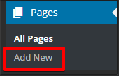  
   *Figure 1.1:* Add a new page.
2. Enter a page title and any text and image content in the editor shown in Figure 1.2.   
     
   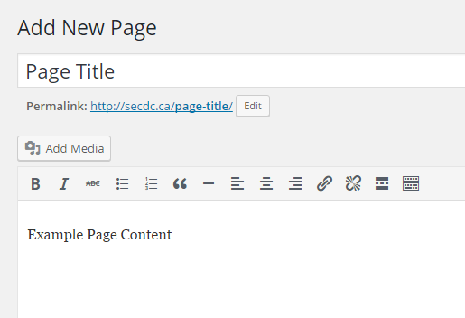  
   *Figure 1.2:* Compose a new page.
3. Select “Publish” to finish creating the page, and select “View page” shown in Figure 1.3 to see the published version of the new page.  
     
   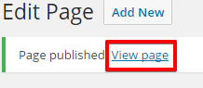  
   *Figure 1.3:* View published page.

#### 

#### 

#### Add a Page to the Main Menu

1. From the administrative dashboard choose “Appearance” and “Menus” as shown in Figure 1.4.  
     
   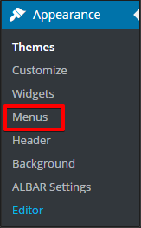  
   *Figure 1.4:* Selecting the “Menus” option.
2. Using the list shown in Figure 1.5, select the page(s) to add to the main menu of the website. Next, select “Add to Menu”.  
     
   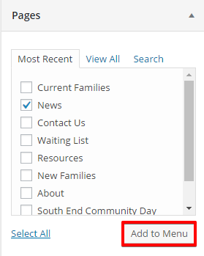  
   *Figure 1.5:* Selecting pages to add to the menu.
3. Drag and drop menu items listed in the “Menu Structure” section shown in Figure 1.6 to adjust their order, then click “Save Menu” to save the changes.  
     
   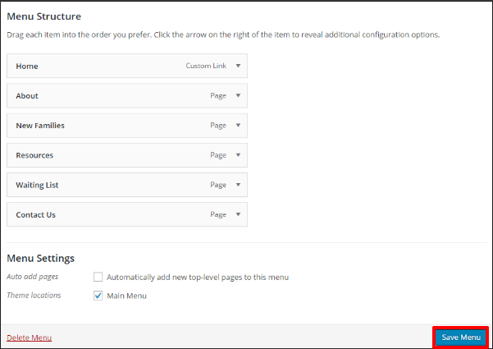  
   *Figure 1.6:* Adjusting the “Menu Structure”.

#### 

#### 

#### Editing Text on a Page

1. Hover over “Pages” in the administrative dashboard and select “All Pages” as shown in Figure 1.7.  
     
   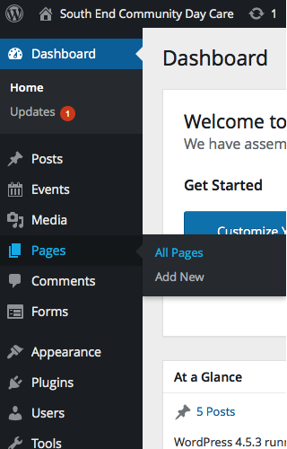

*Figure 1.7:* Administrative dashboard

1. Hover over the name of the desired page and then click the “Edit” option under it as shown below in Figure 1.8.  
     
   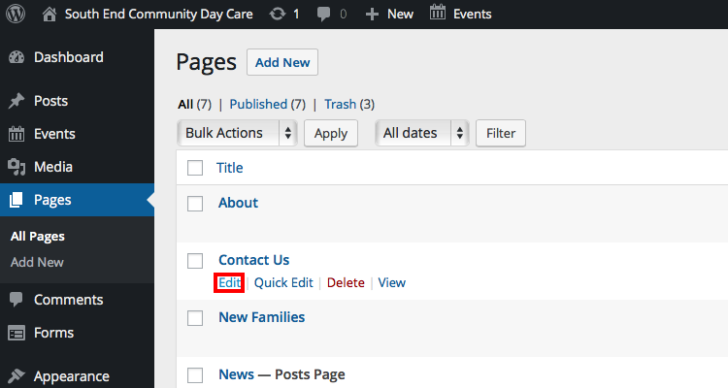

*Figure 1.8:* A view of all pages

1. In the editor, make any desired changes to text, and press “Update” as shown in Figure 1.9.  
     
   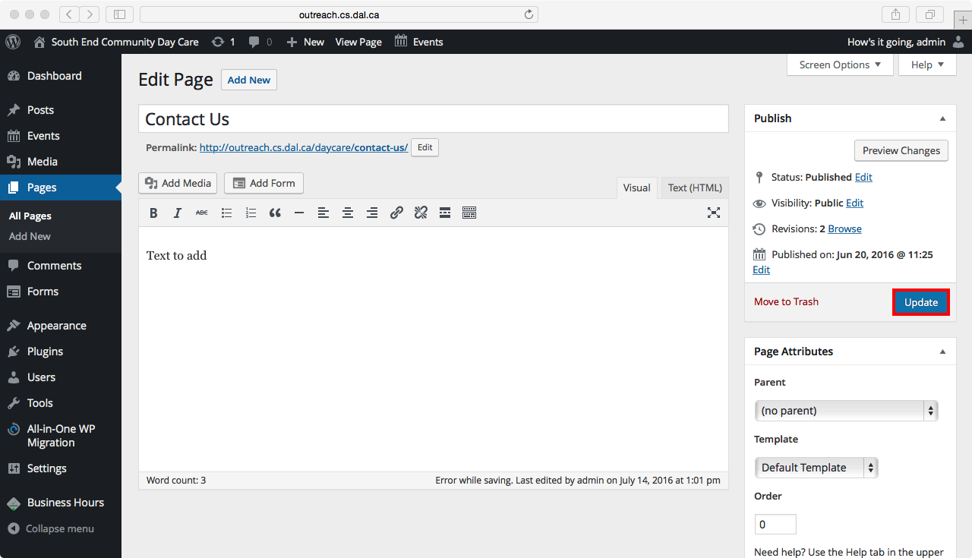  
   *Figure 1.9:* A sample form for creating a page with title “contact us”.

#### 

#### 

#### Adding Images

1. Follow step 1 and 2 of section “Editing Text on a Page”.
2. Hover over the name of the desired page and press “Edit” as shown in Figure 1.10.  
     
   

*Figure 1.10:* A view of all pages

1. Place the cursor in the editor where the image should be displayed, and press the button that says “Add Media” to add the image as shown below in Figure 1.11.  
     
   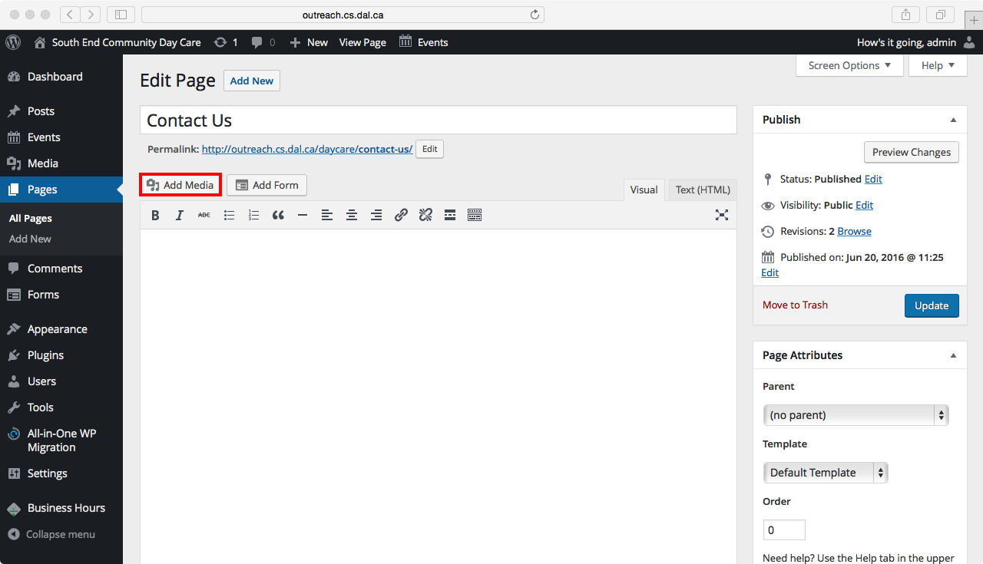

*Figure 1.11:* A page editor

1. Select the “Upload Files” tab and press “Select Files” as shown below in Figure 1.12, or choose “Media Library” to select an existing file.  
     
   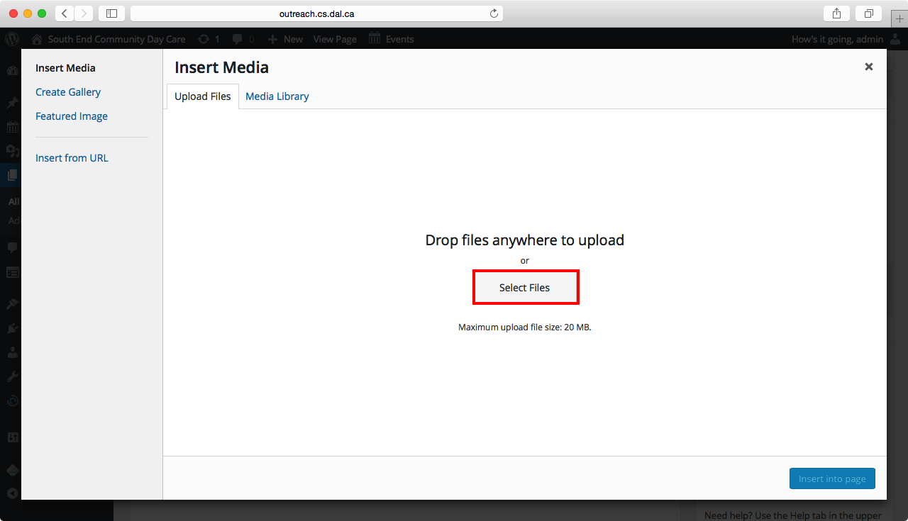

*Figure 1.12:* “Insert Media” interface

1. If uploading a new file, follow the prompts to select the image using a file explorer.
2. Add an optional caption as shown below in Figure 1.13.  
     
   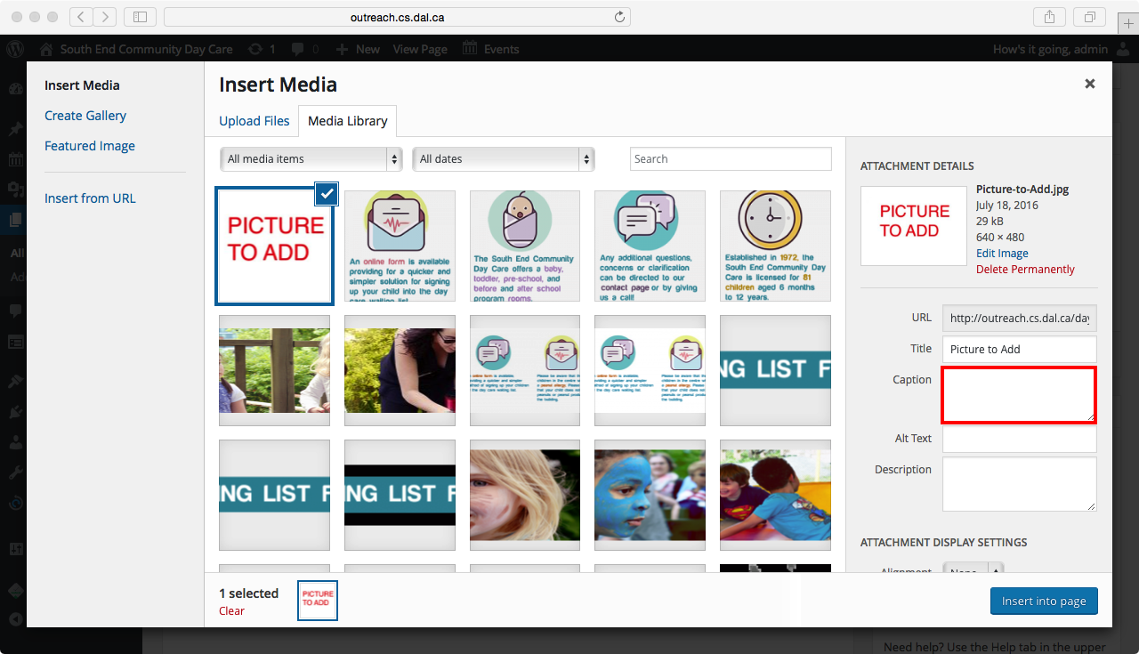

*Figure 1.13:* Add a caption to an image

1. After the image has been uploaded, select “Insert into page” as shown below in Figure 1.14.  
     
   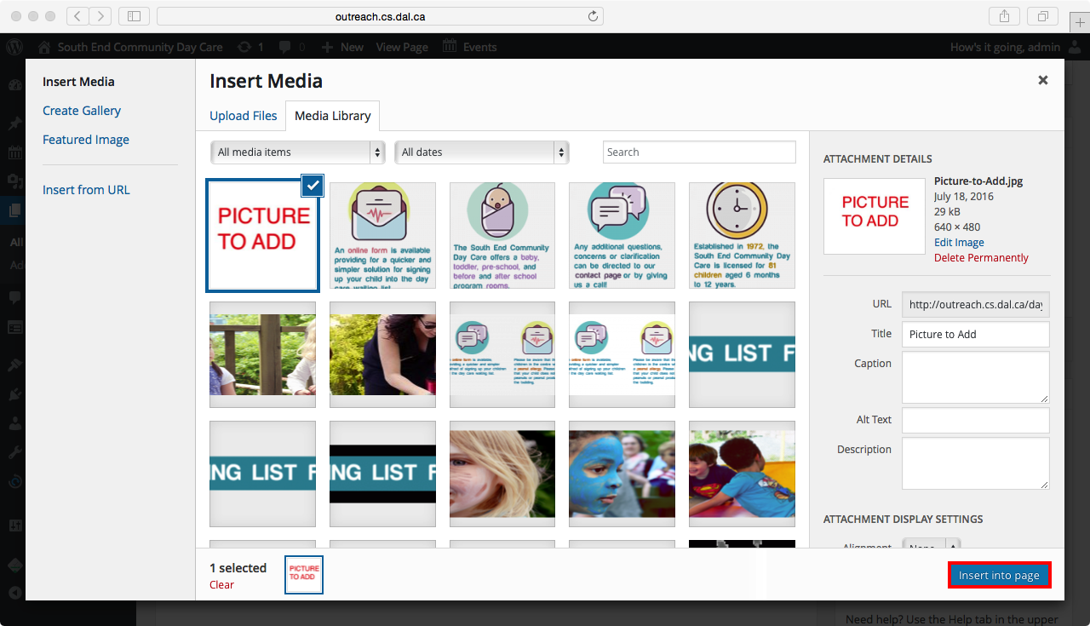

*Figure 1.14:* Insert image into page.

1. Press “Update” to save the changes as shown below in Figure 1.15  
   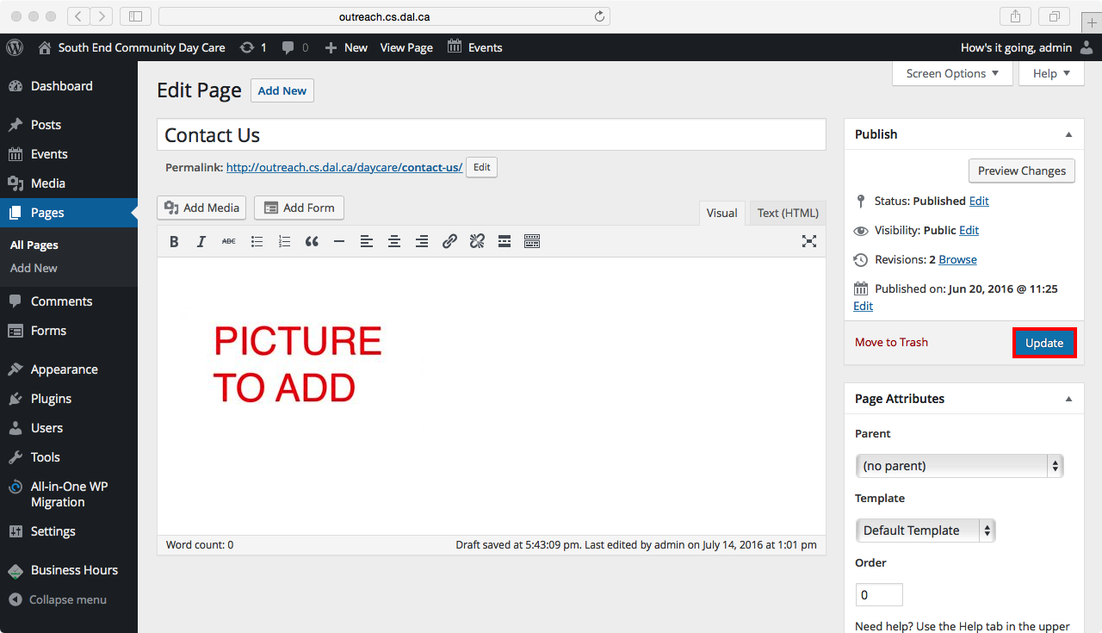

*Figure 1.15:* A view of a page editor with an image in the page.

#### Removing Images

1. Follow step 1 and 2 of section “Editing Text on a Page”.
2. Hover over the name of the desired page and press “Edit” as shown below in Figure 1.16.   
     
   

*Figure 1.16:* A view of all pages.

1. Highlight the image in the text field and press “x” to remove it from the page as shown below in Figure 1.17.  
     
   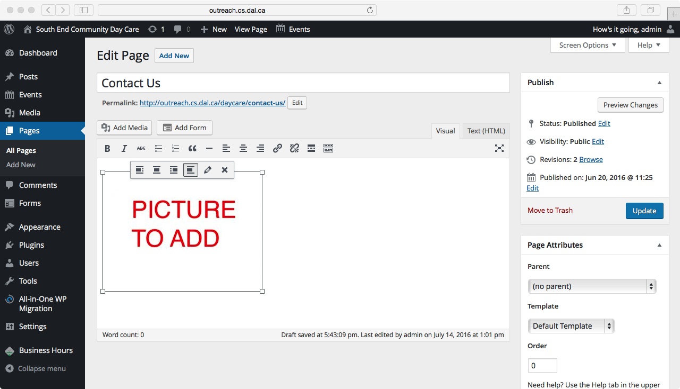

*Figure 1.17:* Selecting an image in the page editor.

1. Press “Update” to save changes as shown below in Figure 1.18.  
     
   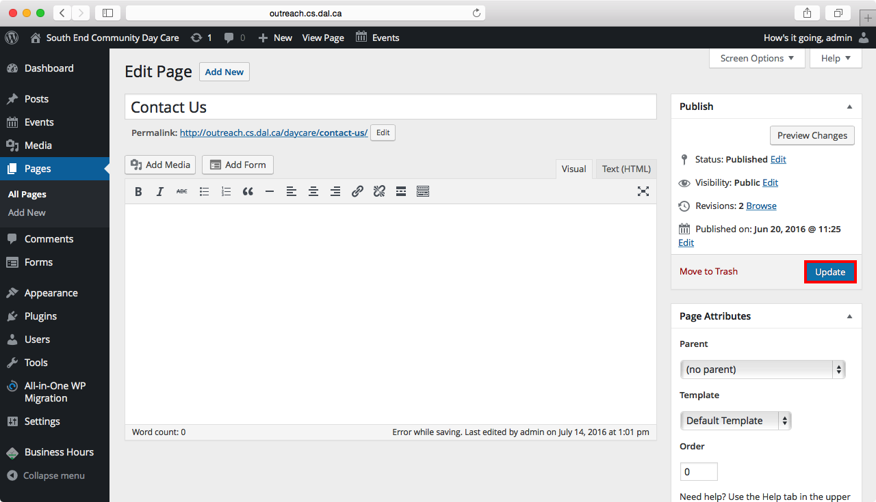

*Figure 1.18:* The page editor highlighting the “Update” button

#### 

#### 

#### Update Account Password

1. Hover over “Users” in the dashboard and select “All Users” as shown below in Figure 1.19.

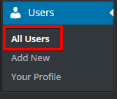

*Figure 1.19:* A view of the “Users” sub-menu.

1. Scroll down and click on “Generate Password” in the Account Management section as shown in Figure 1.20.  
     
   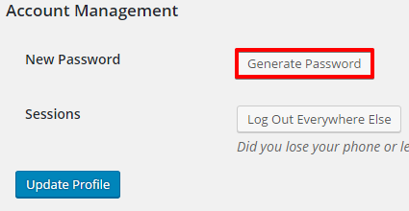

*Figure 1.20:* Generating a new password.

1. Enter a new password that is evaluated to be “Strong” and press “Update Profile” to save the new password as shown below in Figure 1.21.

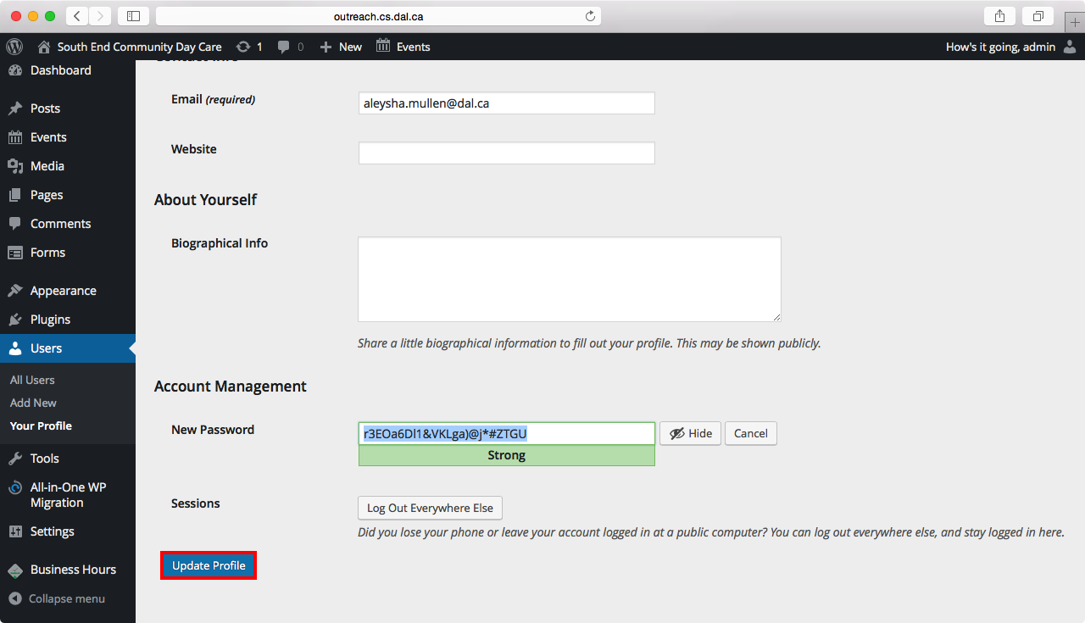

*Figure 1.21:* Example of inputting a strong password and saving the updates.

#### 

#### 

#### Update Plugins

1. Hover over “Plugins” in the Dashboard and select “Installed Plugins” as shown in Figure 1.22  
     
   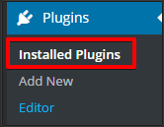  
   *Figure 1.22:* The administrative dashboard displaying the “Plugins” sub-menu.
2. To update all the plugins that need updating at once, select the checkbox next to each plugin that requires updating. Next, click “Bulk Actions” as shown below in Figure 1.23.  
     
   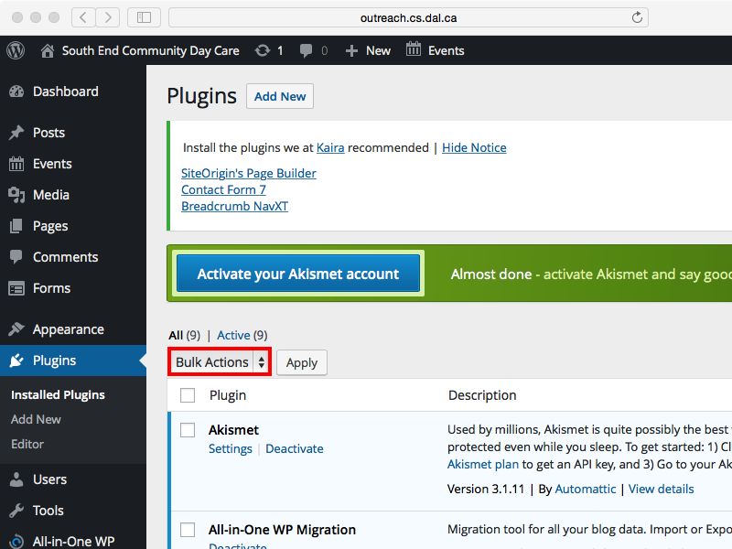

*Figure 1.23:* A view of all plugins.

1. From the dropdown menu, select “Update”, as shown in Figure 1.24.   
     
   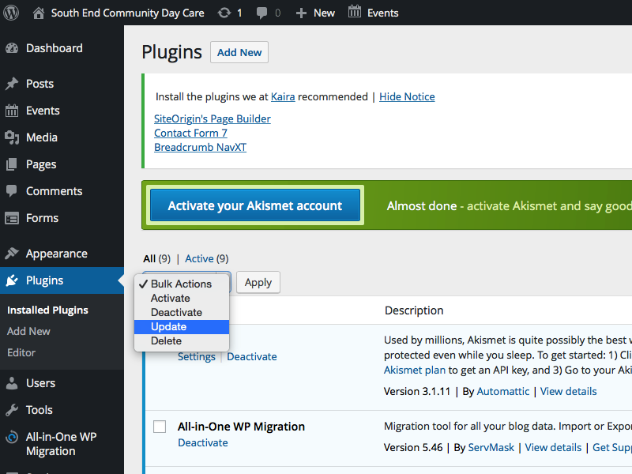

*Figure 1.24:* Updating all selected plugins.

1. Click on “Apply” to update all the selected plugins as shown in Figure 1.25.  
     
   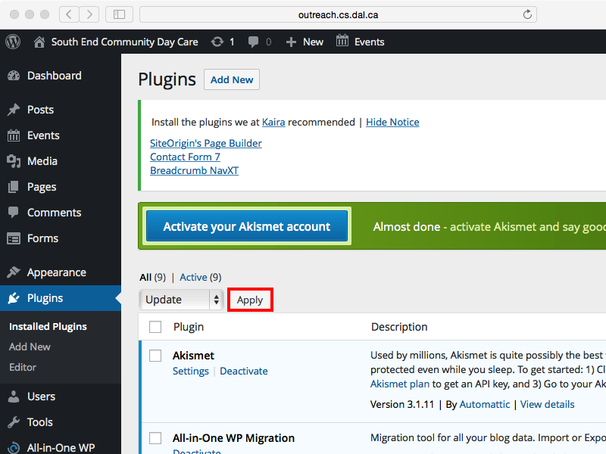

*Figure 1.25:* Applying updates to all selected plugins at once.

1. Otherwise, if you would like to update a single plugin, select “update now” from the list of actions under the name of the plugin as shown in Figure 1.26.  
     
   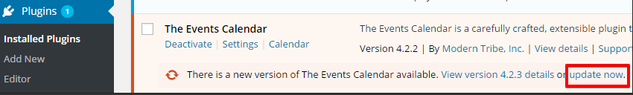

*Figure 1.26:* Updating a single plugin.

### 

### 

### Edit Slider Images and Albar Settings

The slider image is the selection of feature images that display on the front page of the website as seen in Figure 2. 1 and 2.2. Many images can be uploaded to be used as a slider using this tutorial.



*Figure 2.1:* A sample picture of dimensions 1600px wide and 200 px.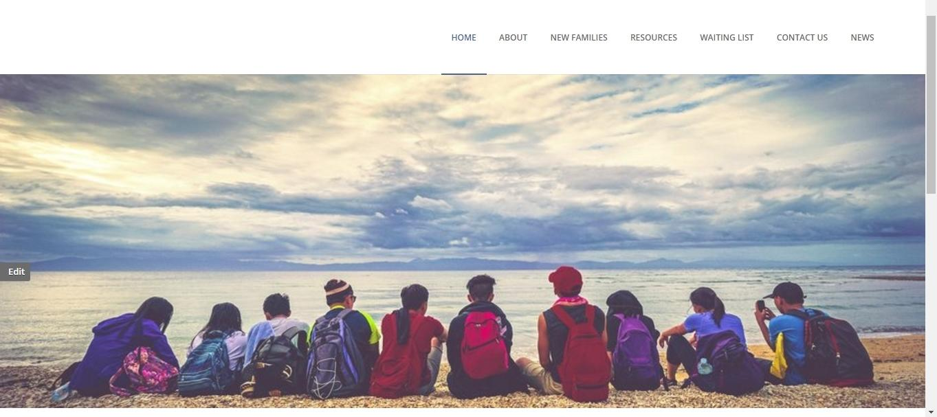

*Figure 2.2:* A sample picture of dimensions 1600px wide and 200 px.

A good rule of thumb for slider images is to have the same image dimensions for all images. They should be at least 1600px wide and 200 px in height. The default dimensions of the current slider images are: 1600px wide and 543px in height.

Px stands for pixel which is what online images are composed of. The recommendation of 1600 by 543px allows for the slider to look uniform with the width of the layout.

Exceeding the recommended dimensions of the slider may cause the website to load more slowly and overshadow the rest of the content. For example, if the slider image is too large such as 3000px in width and height it will make the page load much slower. This slow loading time will be exaggerated for mobile users and will push the remaining content lower onto the page.

#### Add a new Slider Image

1. The dimensions of an image can be seen by right-clicking on the image in a file explorer and selecting ‘Properties’ at the bottom of the menu as seen in Figure 2.3.  
     
   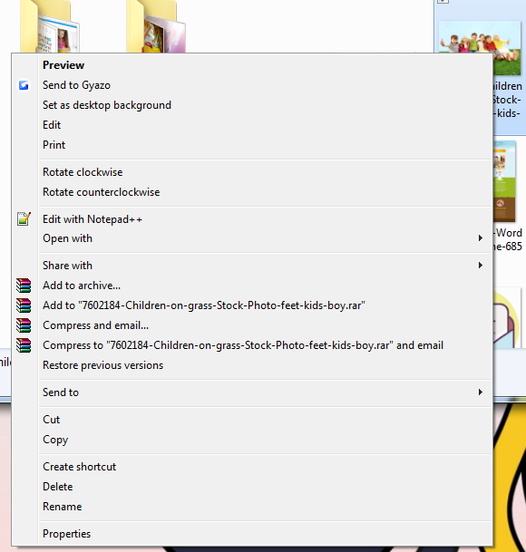  
   *Figure 2.3:* Drop down menu after right clicking on an image.
2. Next, navigate to the ‘Details’ tab to reveal the actual dimensions of the image as seen in Figure 2.4.   
     
   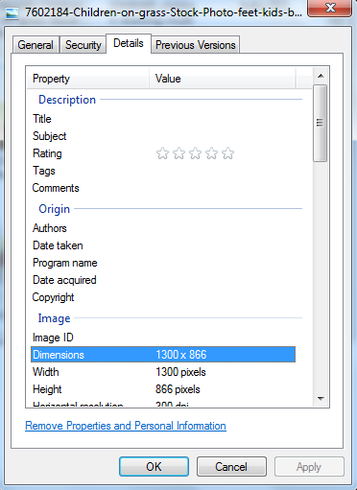  
   *Figure 2.4:* checking properties/dimensions of picture.  
     
   It is possible to crop and resize images to the suggested dimensions by downloading an image manipulation or graphic software such as Adobe Photoshop.
3. Once an image is ready to be displayed as a slider, select “Posts” from the administrative dashboard in WordPress, and select “Add New” as seen in Figure 2.5.  
    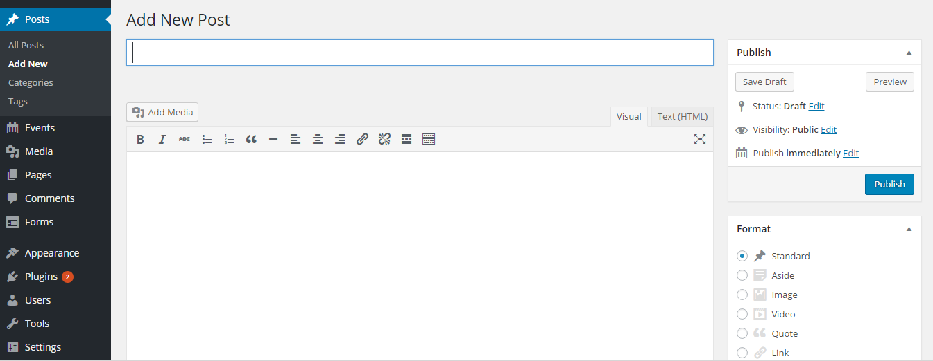*Figure 2.5:* Adding a new slider post sample form.
4. In order for the slider to be uploaded to the website it requires three components: a slider title, feature image, and category. A category known as ‘Slider Post’ as seen in Figure 2.6 has already been created for the admin so it will not be necessary to create another one.  
    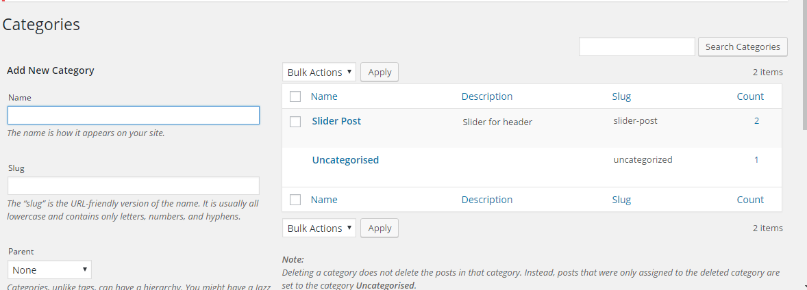*Figure 2.6:* Possible post categories.
5. The post title as seen in Figure 2.7, is unimportant as it will not be displayed anywhere on the website but should be descriptive of the slider image for better administrative organization.  
    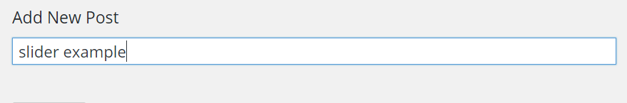*Figure 2.7:* Title field for a new post.
6. When a title has been added, scroll to the categories box and check the ‘Slider Post’ category as seen in Figure 2.8.  
     
   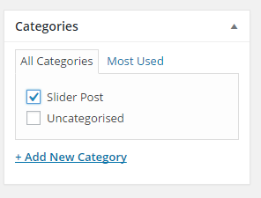  
   *Figure 2.8:* Defining the category of a post.
7. Upload the slider image under ‘Featured Image’ as seen in Figure 2.9. Clicking ‘Set featured image’ will reveal a pop-up window.  
     
   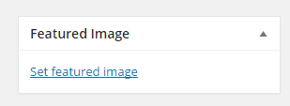  
   *Figure 2.9:* set a featured image as option.
8. The pop-up window will display two tabs as shown in Figure 2.10. The first tab is the ‘Media Library’ which is a compilation of any images previously uploaded while using WordPress for the website.  
     
   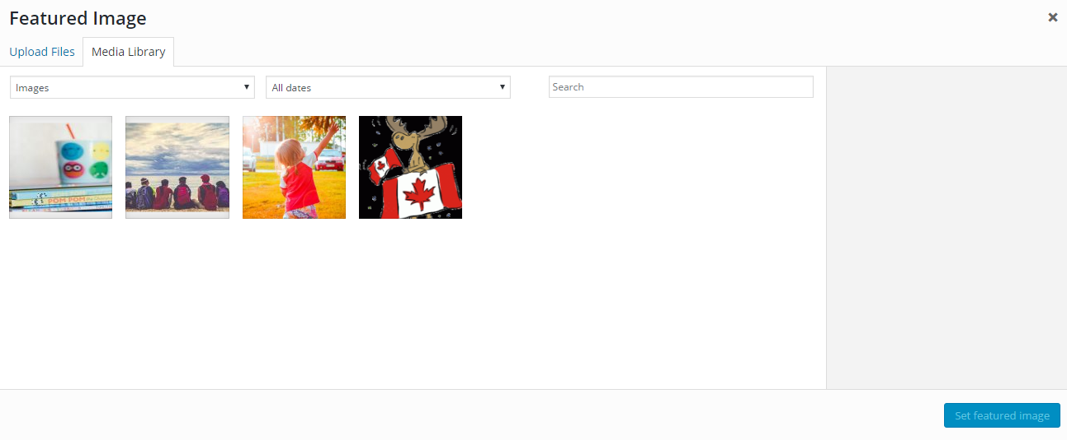  
   *Figure 2.10:* Pop-up to select an image.
9. To upload a new image, select the left-most tab ‘Upload Files’. This will open another new pop-up window as seen in Figure 2.11. Navigate to the directory of the slider image by navigating through the folders. Once the image has been found, select the image and click on ‘Open’.   
     
   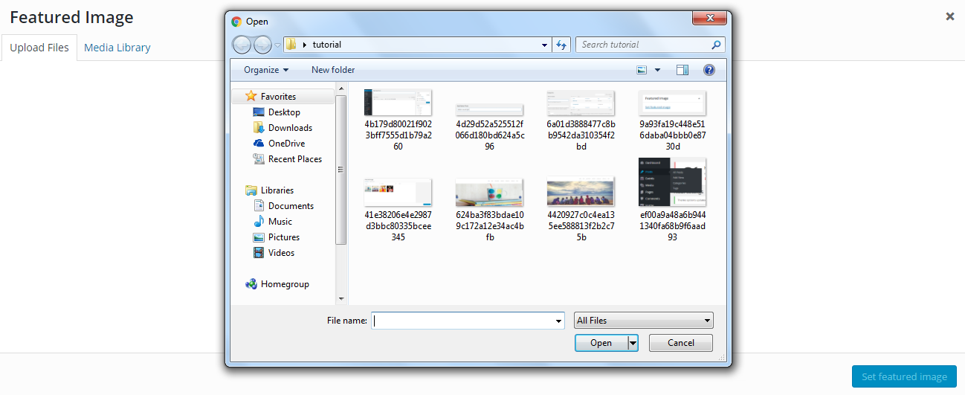*Figure 2.11*: Selecting and uploading image.
10. Click on the ‘Set Feature Image’ button seen in Figure 2.11.
11. After the image has been set, a preview of the image will be revealed in the ‘Featured Image’ box as seen in Figure 2.12.  
      
    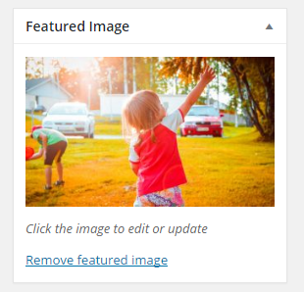  
    *Figure 2.12:* A sample feature image.
12. The last step is to publish the slider post by pressing the ‘Publish’ button as seen in Figure 2.13.   
      
    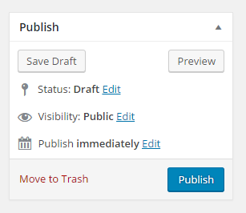  
    *Figure 2.13:*  Publishing a post.
13. When the admin wishes to upload another slider, perform the above steps with a new title name for each slider image. If the admin decides to later want to remove a slider image, click on the ‘Post’ tab again and it will reveal a list of all posts created. Hovering the cursor over the title of the slider they wish to remove will reveal a ‘delete’ text in red and clicking on it will delete the respective slider as seen in Figure 2.14.  
      
    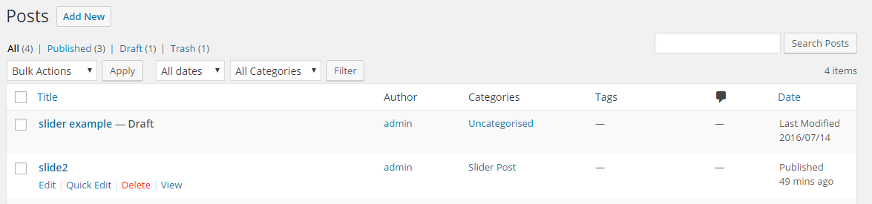*Figure 2.14:* A list of all existing posts.

#### 

#### 

#### Edit Albar Theme Settings

Albar is the theme used for the website’s layout. To access the Albar settings for some basic customization navigate to the dashboard and under the “Appearance” menu will be ‘ALBAR Settings’ as seen in Figure 2.15.  
  
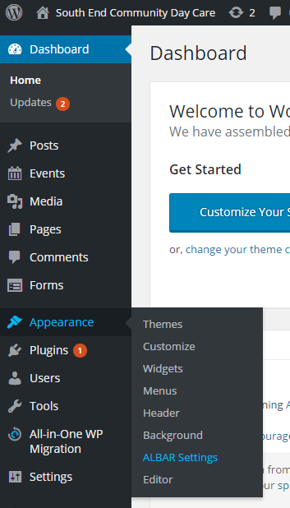  
*Figure 2.15:* Albar Menu

By navigating to the Albar settings, it is possible to change some of the website’s appearance without having to alter any code. Examples of possible changes include, changing the color of the text, and the font-styles. The Albar settings page also has example formats to reference and the default format commented as seen in Figure 2.16.  
  
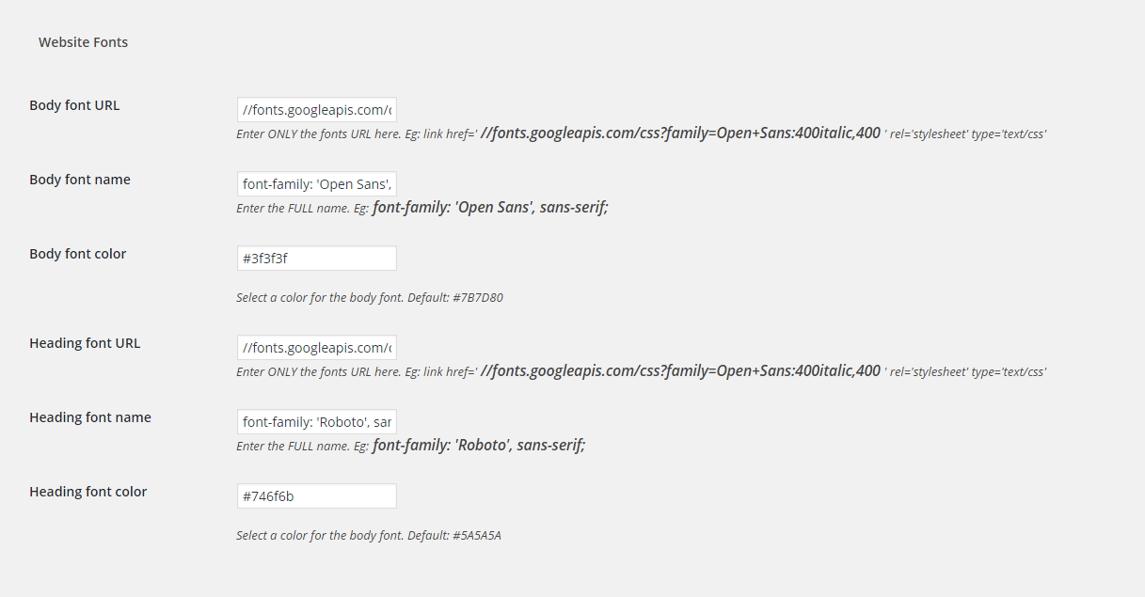  
*Figure 2.16:* Albar Settings

Finally, it is also possible to quickly change the address, phone number, and email address of the Day Care under Albar settings as seen in Figure 2.17 which will update the top-most header text on the website.  
  
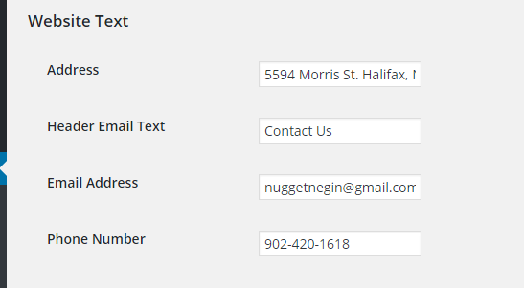  
*Figure 2.17*: Albar Settings, Website Text

### 

### 

### Add Video to a Page

For the purpose of maintainability, the team has opted to use the embedding YouTube videos as a method of adding videos to a page. In order to embed a video from YouTube, the video must first be available on youtube.

1. To upload a video to YouTube is simple, follow the steps in this YouTube video tutorial to upload a video: <https://www.youtube.com/watch?v=aHocQeo9ibY&feature=youtu.be>
2. When the video has been uploaded to YouTube, find the page to add a video to in the WordPress administrative dashboard by clicking on “Pages” as shown in Figure 3.1.  
     
   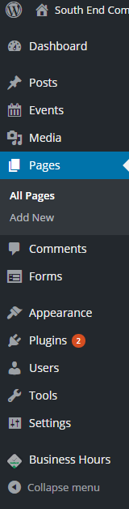  
   *Figure 3.1:* Dashboard options
3. Find the page where the video will be displayed from the list of existing pages as shown in Figure 3.2. Hover the cursor over the page name to see the management options.  
     
    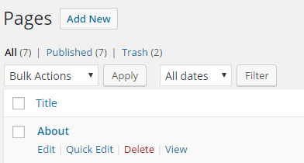  
   *Figure 3.2:* Table of List of existing pages.
4. Select “Edit” to edit the page. The page selected should appear in the page editor as shown below in Figure 3.3.  
     
   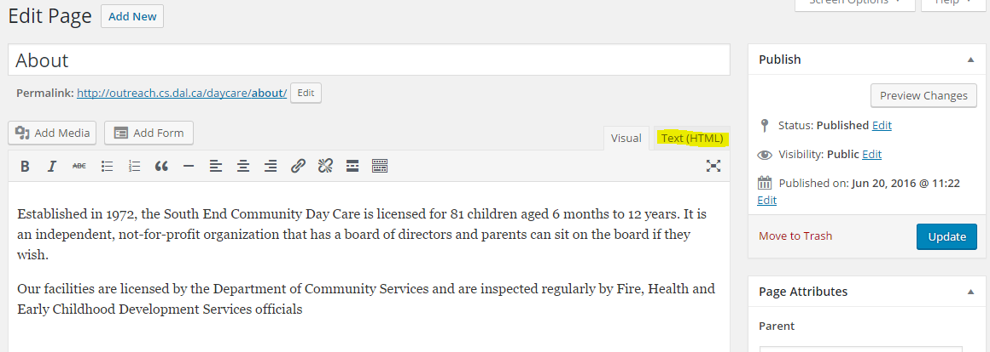  
   *Figure 3.3:* Editing/updating a page.
5. Select the tab “Text(HTML)” seen in Figure 3.3. Do not be alarmed if the page content looks unpolished under this tab.
6. In another window or browser tab, find the YouTube video to add to the website. Scroll to bottom of the video and click “Share” as seen in Figure 3.4.  
     
   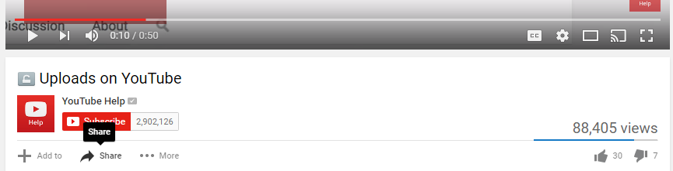*Figure 3.4:* Youtube video details.
7. A menu should be displayed as in Figure 3.5.  
     
   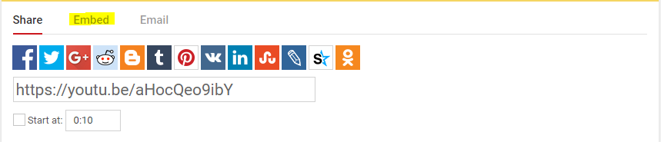*Figure 3.5:* Embed option on YouTube page.
8. Click on “Embed” and copy the highlighted section below in Figure 3.6.  
     
   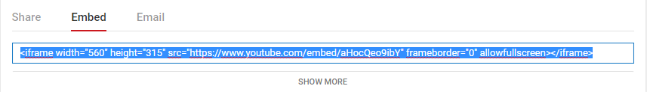*Figure 3.6:* The HTML line of code for posting video on a page.
9. Head back to your WordPress page and paste the embedding code you copied from YouTube into the “Text/HTML” page editor. An example is below Figure 3.7:  
     
    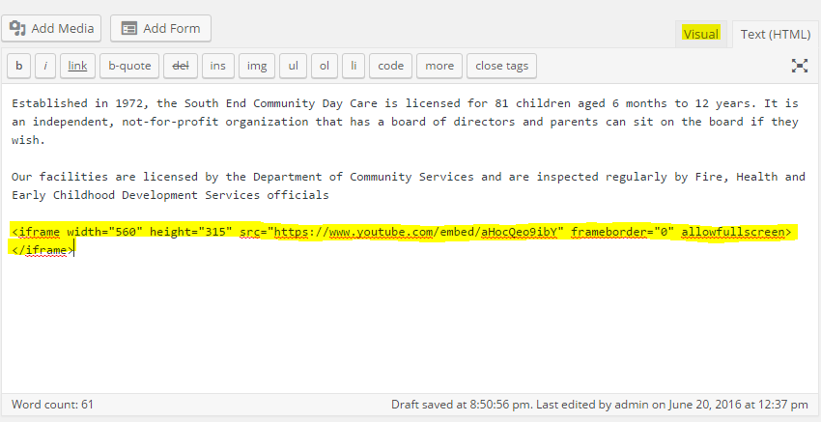  
   *Figure 3.7:* HTML view of a page in editing a page.
10. Select the “Visual” tab in the editor to see a preview of the video in the page as in Figure 3.8  
      
    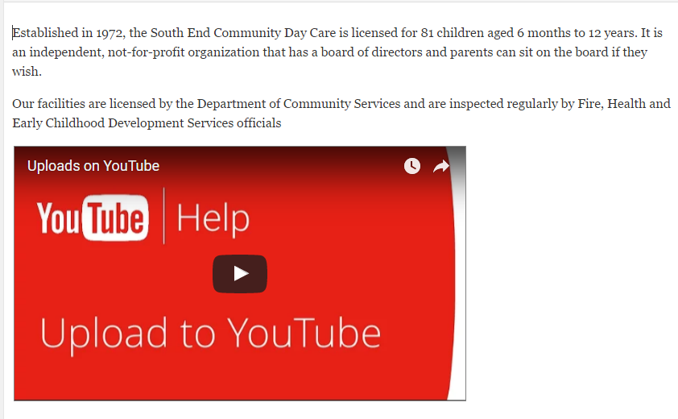  
    *Figure 3.8:* Preview of Video content
11. Select “Update” to save and publish the content.

### Update the Hours of Operation

This feature displays the hours of operation in an organized table in the sidebar of the South End Community Day Care website as shown in Figure 4.1.  
  
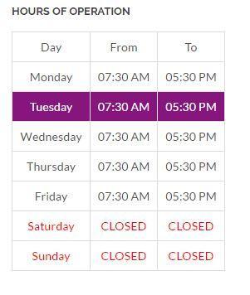  
*Figure 4.1:* The regulars business hours of the facility.

#### 

1. Go to the administrative dashboard and select on ‘Business Hours” as shown in Figure 4.2.  
     
   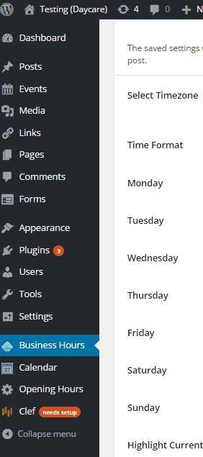  
   *Figure 4.2*: side bar of Admin panel.
2. To update the regular business hours of the facility update any of the fields shown in the schedule form in Figure 4.3.  
     
   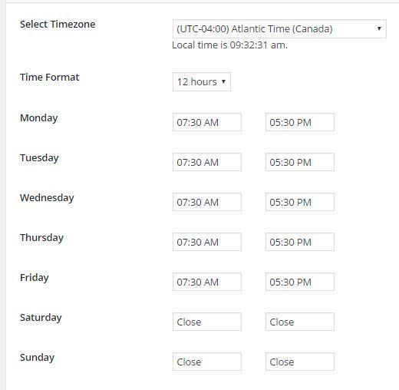  
   *Figure 4.3:* Setting working hours of each day manually.
3. To update the background color of the current day of the week displayed in the sidebar. Select the “Select Color” button shown in Figure 4.4.  
     
   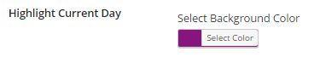  
   *Figure 4.4:* Setting the highlight color of the current week day.
4. To change the font color of the text in the hours of operation table select “Current Color”.
5. When satisfied that updates are complete select the button ”Save Changes”.

### Update Daycare Status

The Daycare Status feature displays the current open/closed status of the daycare on the sidebar of the South End Community Day Care website. This status will automatically update from open to closed and vice versa to correspond to the regular business hours of the facility. However, should the administrator need to manually update the status (for example, in the event of a storm closure), they may follow the instructions below to do so.

1. In the administrative dashboard choose “Appearance” as shown in Figure 5.1  
     
   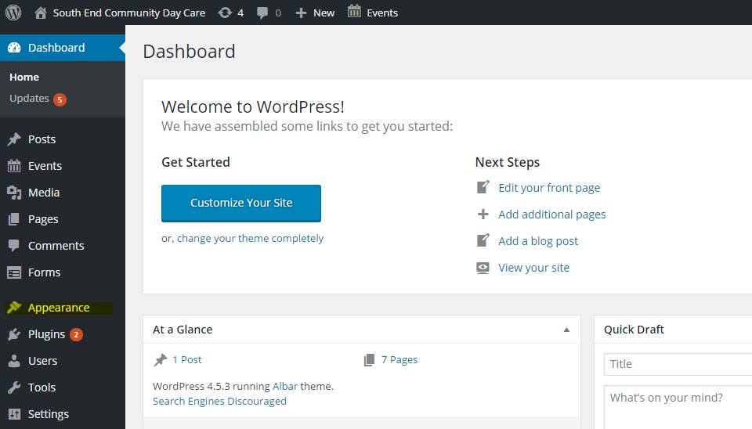  
   *Figure 5.1:* Administrative dashboard.
2. Click on “Widgets” in the Dashboard as shown in Figure 5.2.  
     
   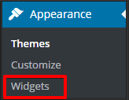  
   *Figure 5.2:* “Appearance” sub-menu
3. Figure 5.3 below shows a set of all widgets and their arrangements. The widgets that display in the sidebar of the pages ‘Home’ and ‘About’ are located in the section “Sidebar”.

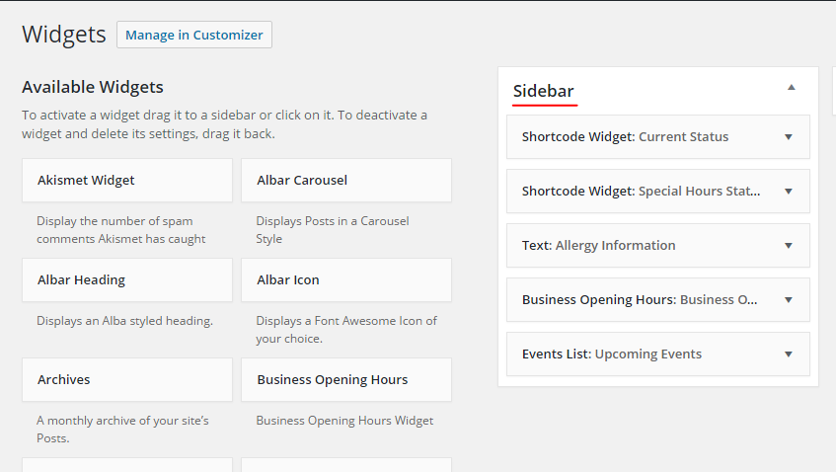

*Figure 5.3:* Set of all widgets and their arrangements.

1. There are two widgets that are used to control the status that is displayed to site visitors:
   1. Shortcode Widget: Current Status  
      This widget displays the status that shows if the daycare is operating under regular business hours.
   2. Shortcode Widget: Special Hours Status  
      This widget is displayed if there is a special closure (such as a snow day), or special hours (like holiday hours).
2. Selecting “Shortcode Widget: Current Hours” should display the content shown in Figure 5.4.  
     
   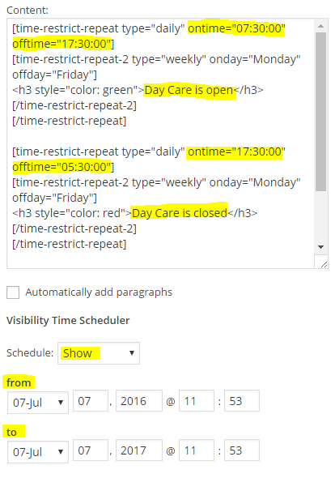  
   *Figure 5.4:* “Current Status” widget editor.
3. The “Content” box in Figure 5.4 contains some special code that controls the status message and causes it to turn from Open to Closed automatically. You can see the highlighted “on time” is set to 7:30. This means that the message in this block will display at 7:30am. By altering this time, you can change the regular open hours of the facility.

The highlighted off time is set to 17:30 (5:30pm), by altering this number you can alter the closing hours of the facility. Likewise, in the second paragraph, the hours for the closed status are set.   
  
**You should not need to change anything in the content box if you have a snow day or a holiday closure. This information should be changed only if the regular business hours of the facility change.**

1. The drop-down “Schedule” in Figure 5.4 controls whether the regular hours display in the sidebar of the website or not. In the case of a special closure like a snow-day or a holiday, simply schedule the “Current Status” widget to hide until the closure is over.   
     
   Choose “Hide” from the dropdown menu, and then choose the interval during which the regular hours status should be hidden. If you are creating a special closure for a snowday, you probably only want to create a one day interval. If you are closing the facility for the holidays, you can schedule the regular hours to be hidden for several days.  
     
   For example, the Figure 5.5 below shows what the Current Status schedule might look like during the holidays:  
     
   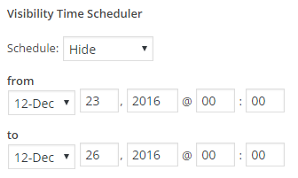  
   *Figure 5.5*: Hiding the “Current Status” widget for a special closure.
2. When the interval for hiding the regular status has been selected, choose “Save”.
3. Next, create a similar schedule for the “Special Hours” widget so that the special closure status shows when the regular status is hidden. Figure 5.6 below shows the “Special Hours” schedule that would correspond with the “Current Status” schedule that was set in steps 7-8.  
     
   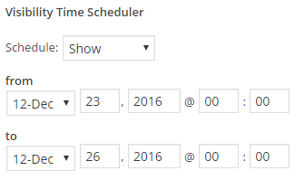

*Figure 5.6*: “Special Hours” schedule to display a special status.

1. To update the message of the special status simply replace the highlighted message in Figure 5.7 below and click “Save”  
   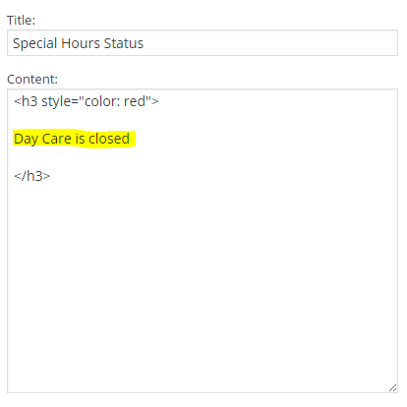  
   *Figure 5.7:* “Special Hours” status message.

### The Event Calendar

The Event Calendar feature displays all events in a calendar format as shown in Figure 6.1. It also displays upcoming events in the sidebar of the ‘Home’ and ‘About’ pages. 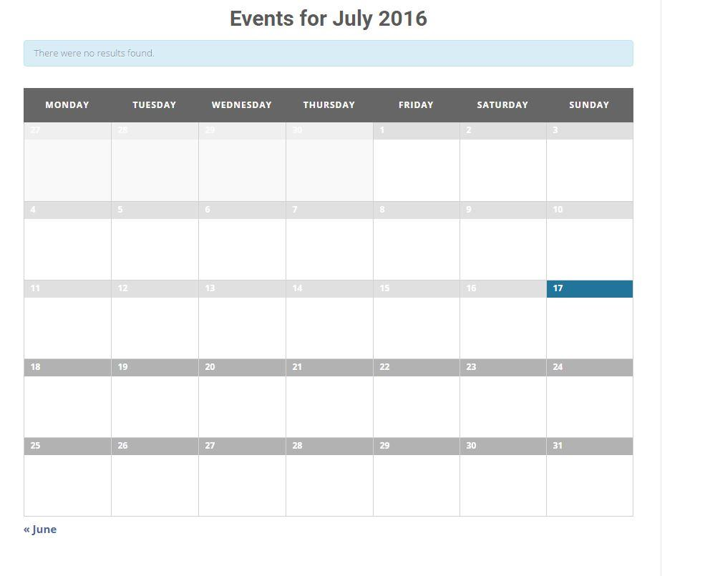

*Figure 6.1:* A view of the Event Calendar

#### 

#### Add an Event to the Calendar

1. On the administration dashboard as shown in Figure 6.2, choose ‘Events”.  
    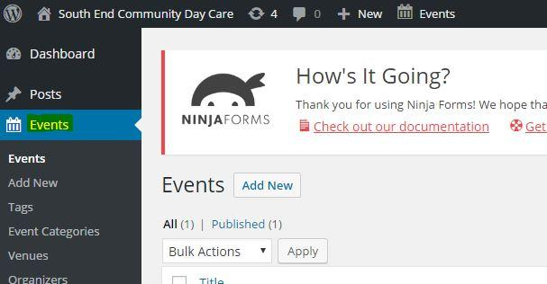*Figure 6.2:* WordPress dashboard
2. On the Events administration page as seen in Figure 6.3, select the “Add New” button. 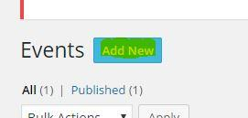  
   *Figure 6.3:* Button highlighted used to add new events.
3. In the form shown in Figure 6.4, fill out information about the event including title, and event detail. The title area has the following text “Enter title here”. The event detail section is the large text field area directly below the title section.  
      
    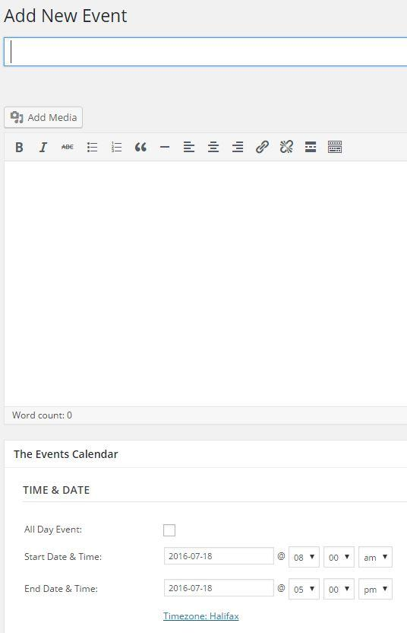  
   *Figure 6.4:* Event detail editor
4. To add media files, such as a images select the “Add Media” Button found below the title text field as shown in Figure 6.5. Next, select the button “Select Files” in the center of the page as shown in Figure 6.6, and select a local media file to upload a new file, or choose a previously uploaded file from the Media Library. Then select “Insert into Post” button at the right bottom of the page.  
     
    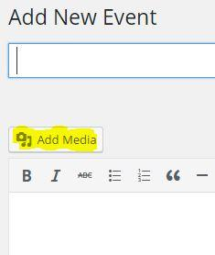  
   *Figure 6.5:* Add Media button  
     
   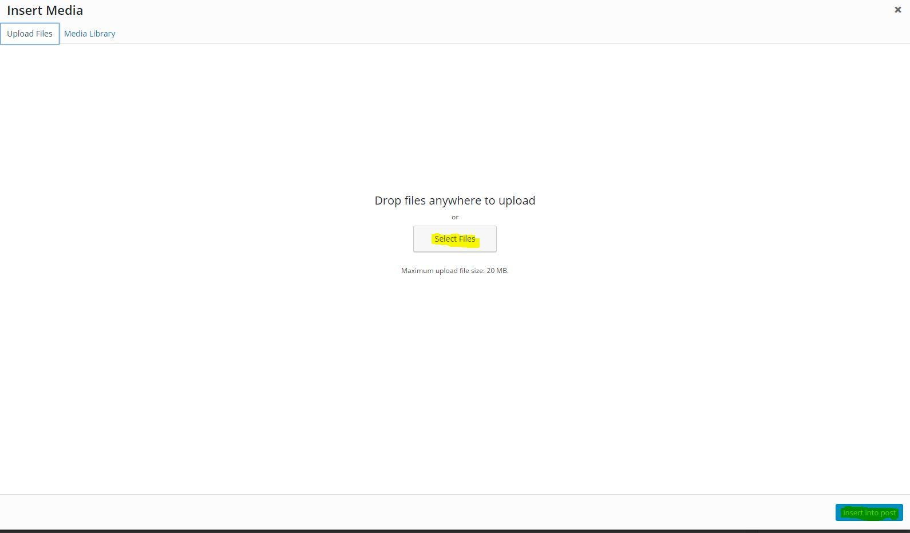 *Figure 6.6:* Selecting a media file from Computer.
5. To add more details about the event such as time, date, location, and event organizer. Scroll down the page and fill out the form shown in Figure 6.7. It should be noted that all of these fields are optional with the exception of the time and date of the event.  
     
    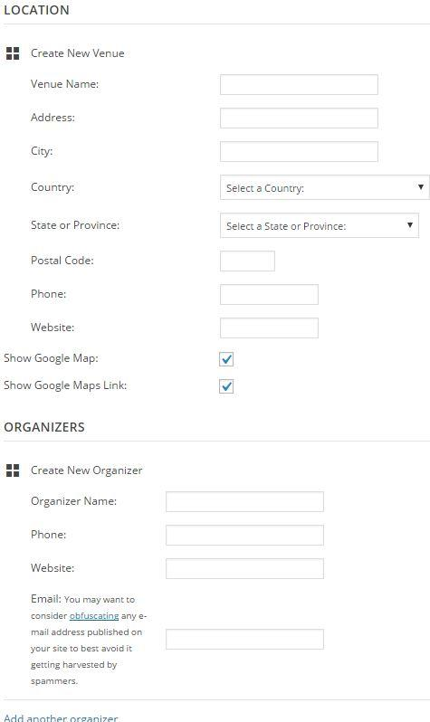  
   *Figure 6.7:* Each field relate to description of an event.
6. Some events can be color coded by daycare age group. If an event is intended for a particular age group, select the age group by checking the appropriate box in the Categories section as shown in Figure 6.8 below.  
     
   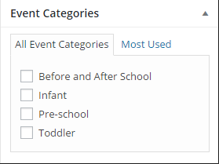  
   *Figure 6.8:* Selecting a category.
7. When the event has been composed, select the “Publish” button as shown in Figure 6.9. This will make the event visible to the public. A message on top of the page will say “Event published” when the event has been published successfully.  
     
   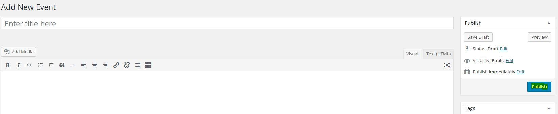*Figure 6.9:* Publishing an event on website.

#### 

#### 

#### Manage Existing Events

1. To manage existing events, navigate to the “Events” main menu by choosing “Events” from the administrative dashboard. This will direct you to a table format of all the events currently existing as shown in Figure 6.10.  
     
   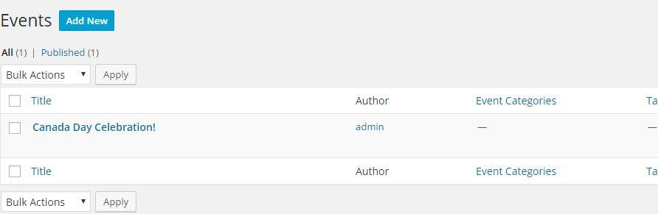*Figure 6.10:* List of currently published events.
2. To delete one of the events in the table, hover the mouse on the event name, or if on a smartphone, select the event name. Options will appear as shown in Figure 6.11. Select “Trash” to delete the event.  
     
   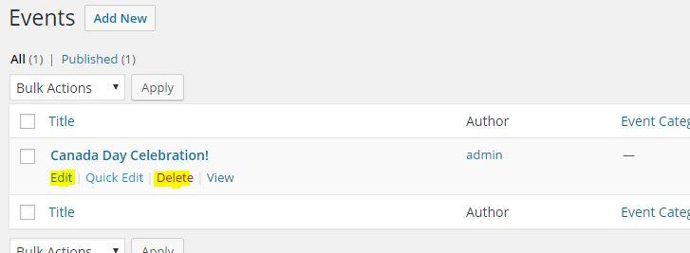*Figure 6.11:* Management options for events
3. To update and make changes to an event, hover over the event and select “Edit”. Make any changes to the event details and select “Update” to save and publish the changes made.

### The Waiting List

The waiting list feature allows visitors to add their children to the facility waiting list by filling and submitting the form shown in Figure 7.1. This feature also automates some of the waiting list management by collecting and organizing the submission data.

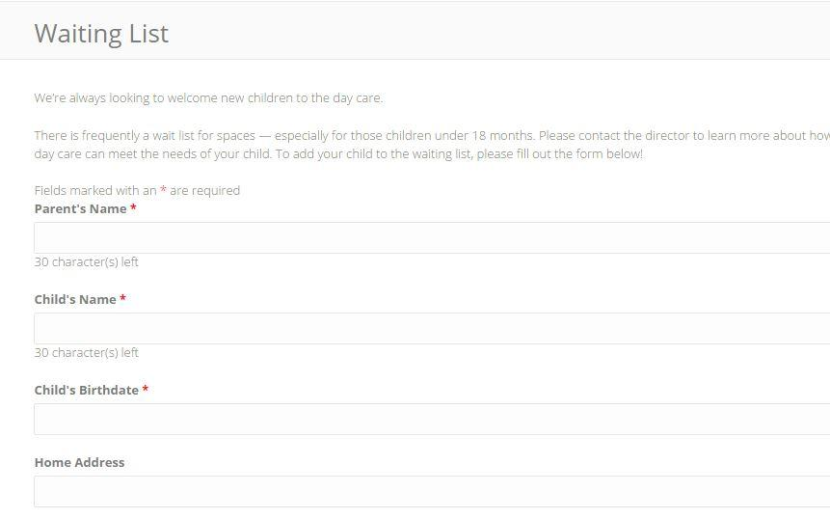

*Figure 7.1*: A sample waiting list form.

#### 

#### 

#### Access Waiting List Submissions

1. On the administrative dashboard select “Forms” as shown in Figure 7.2. This section provides access to all the forms used on the website including the “Waiting List”.   
     
   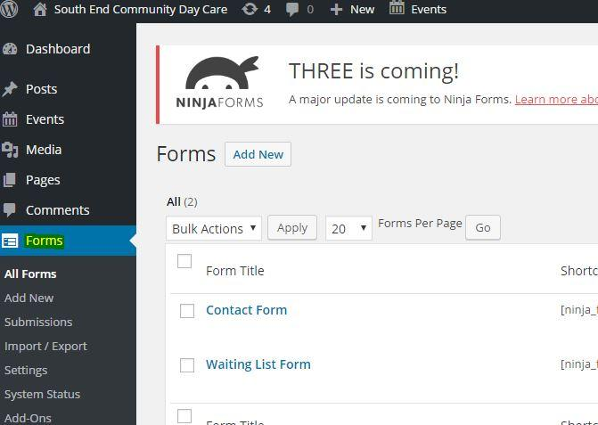  
     
   *Figure 7.2:* Form management dashboard
2. Hover the mouse over “Waiting List Form” or, if on a smart device, simply touch the form name. Multiple options will be available. Select “View Submissions” as shown in Figure 7.3.  
     
   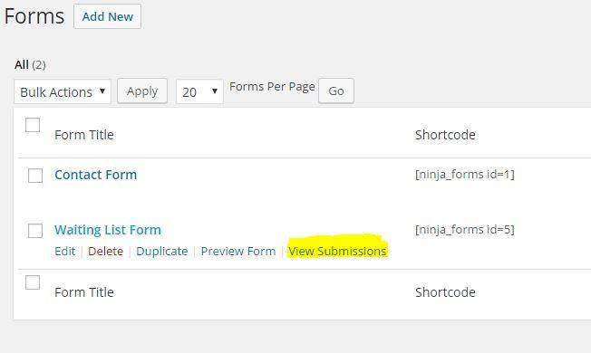*Figure 7.3:* List of existing forms.
3. A list of submissions from the waiting list form will be visible like in Figure 7.4. Select a column name to sort the table data by that column.  
     
   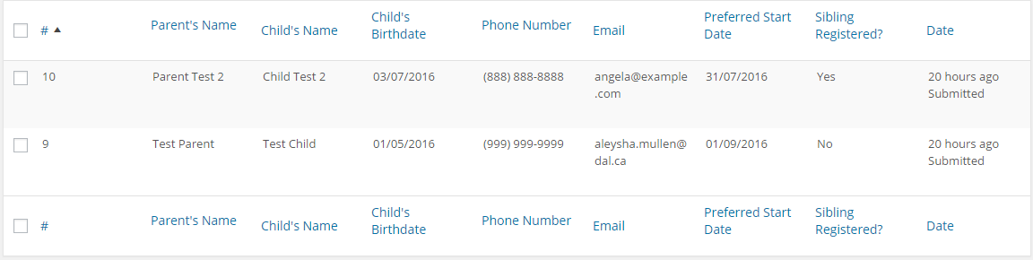  
   *Figure 7.4:* Sample submissions data
4. Edit any entry in the submissions table by hovering over it and selecting “Edit”. Likewise, remove any entry in the submissions table by hovering and selecting “Trash”.
5. To change which columns appear in the submissions table, select “Screen” options as shown in Figure 7.5.  
     
   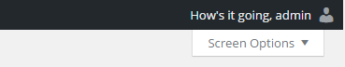  
   *Figure 7.5:* Screen options
6. Check or uncheck the options presented to add or remove columns from the submissions table display.

#### 

#### 

#### Edit the Waiting List Form

1. To update the waiting list form, select “Forms” from the administrative dashboard. Hover the cursor over the form that requires an update, and select “Edit”.
2. Select “Build Your Form” as shown in Figure 7.6.   
     
   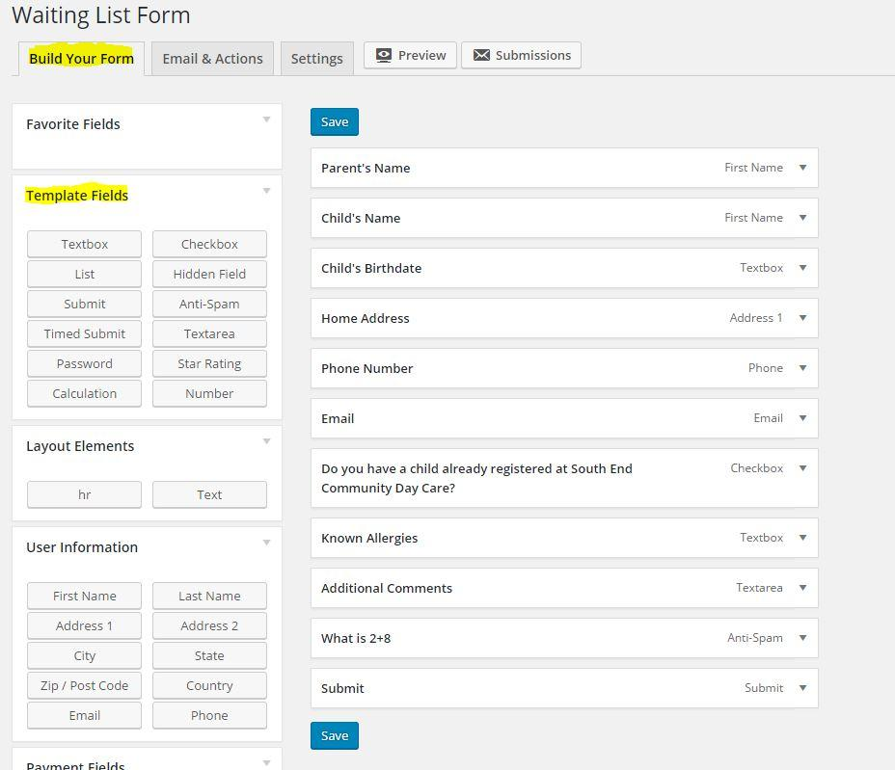  
     
   *Figure 7.6:* Fields used to customize form.
3. The “Build Your Form” editor shown in Figure 7.6 contains all the fields present in the waiting list form. To edit any of these fields simply click to select them. Figure 7.7 shows the “Parent’s Name” field expanded for editing.  
     
   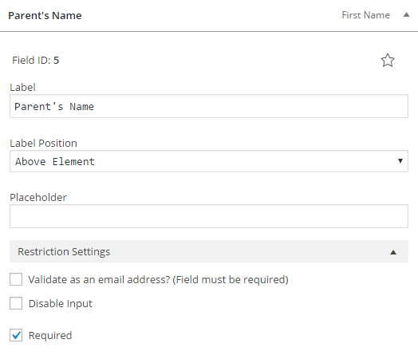  
   *Figure 7.7:* “Parent’s Name” field editor
4. Make any desired changes to form fields and select “Save”.

#### 

#### 

#### Edit Waiting List Notifications

1. When the waiting list form is submitted a notification email is sent to the site administrator. To update the notification email, select “Forms” in the WordPress administration dashboard.
2. Select “Waiting List Form” then “Email & Actions”, and finally “Notification of new Waiting List Entry” as shown in Figure 7.8.   
     
   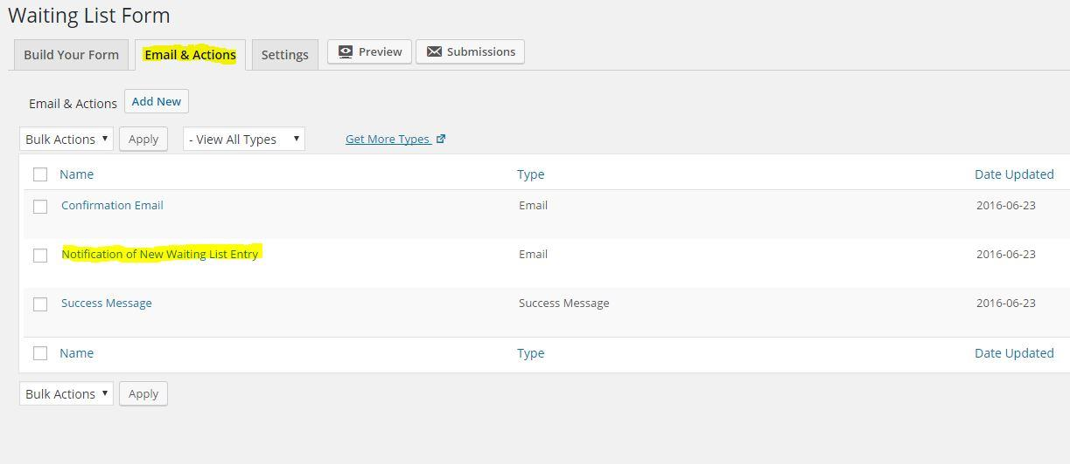*Figure 7.8:* Table of all form notifications
3. Edit the “Action” form shown in Figure 7.9.   
     
   The “To” area is the email that will receive the waiting list submissions emails. “Subject” refers to the subject header of each email. And finally “Email Message”, which will provide detail of the submission. Tags refer to specific data. Ex. [ninja_forms_id=13] as shown in Figure 7.9, so take care when making changes to this section.  
     
   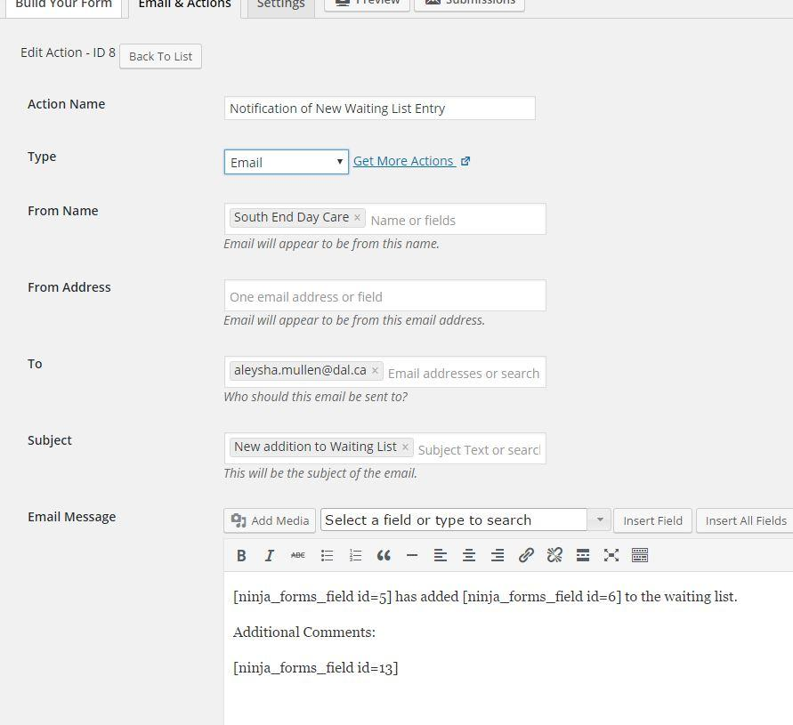*Figure 7.9:* Setting an action and email notification details.
4. When the waiting list is submitted a success message is shown to the user. To change the response message to visitors after they submit the waiting list, select “Email & Actions”, and “Success Message”. Repeat step 3 to edit the “Success Message” action in the same way the “Notification of New Waiting List Entry” action was edited.

### 

### 

### Common Problems

**I just made a change but I don’t see it on the website.**

Be sure to press the “Update” button on the side bar every time you make a change so no changed are lost and to you are able to see them on the website.

**I added something to the website and pressed “Update” but I still do not see it.**

If you cannot see some content that should be displayed in the sidebar, make sure the “show” option is selected in the widget settings instead of the “hide” option.

**I clicked an icon/picture on the front page and it does not go to the page that I want it to go to.**

Make sure to check the destination url of the icon in the page editor and that the link is set to the preferred location.

**I just added a new page and I cannot find it on the website.**

Follow the instructions to add it to the main menu so that you can find it easily.

**A picture that I have chosen for the slider is not showing up on the front page.**

Be sure to set the post category to “Slider” so that it displays among the images on the front page.

**I have added a slider image but it is stretched out.**

Try cropping it the image in different ways using the recommended dimensions as guidelines to get the best possible version of the picture.

If there are any unresolved questions, try these troubleshooting pages.

For Wordpress: <https://codex.wordpress.org/Troubleshooting>

For the waiting list and forms: <http://docs.ninjaforms.com/?docs=true>